INSTALLATION OF PYTHON 3.9.8

|  |  |
| --- | --- |
| Date | 03 November 2022 |
| Team ID | PNT2022TMID03606 |
| Project Name | Project – Real-Time River Water Quality  Monitoring and Control System |

Step 1: Type python in google and click on the first link



2: Click the python 3.9.8

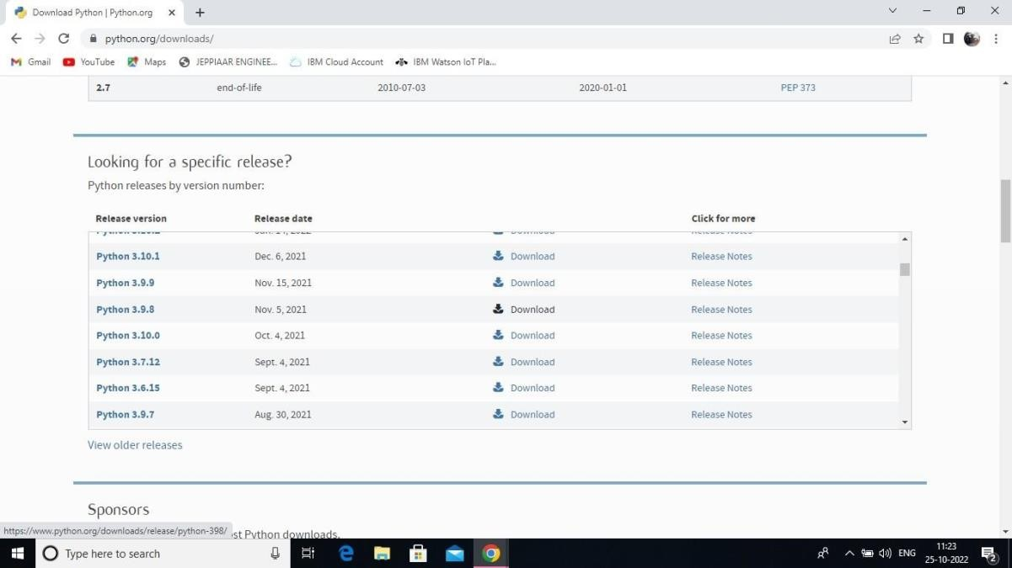

Step 3: Scroll down to reach Files and click on “Window installer (64 bit)

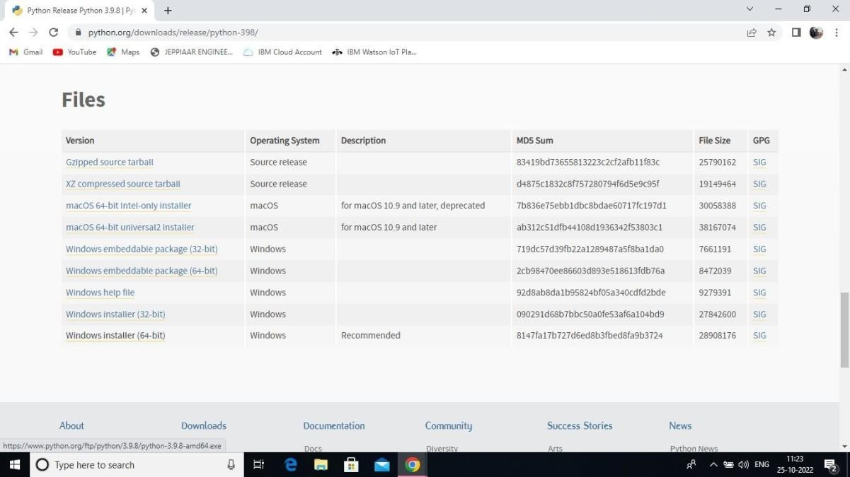

4: Click on the Install button.

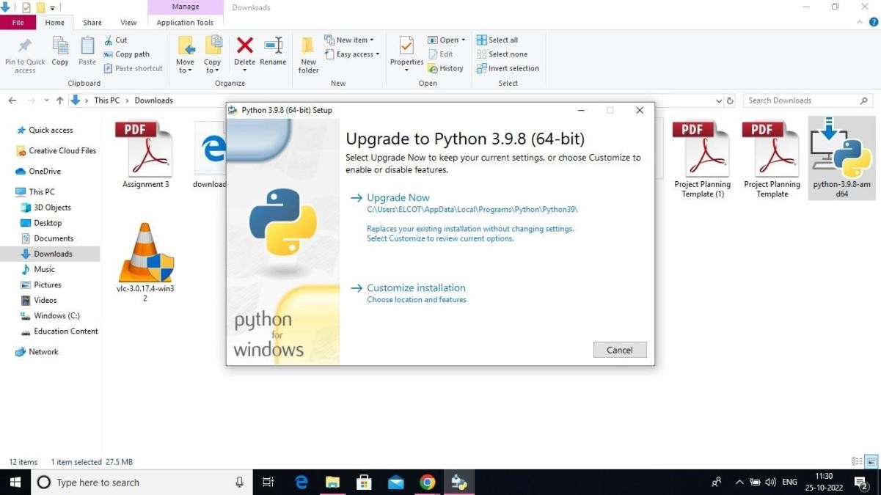

Step 5: Installation on progress

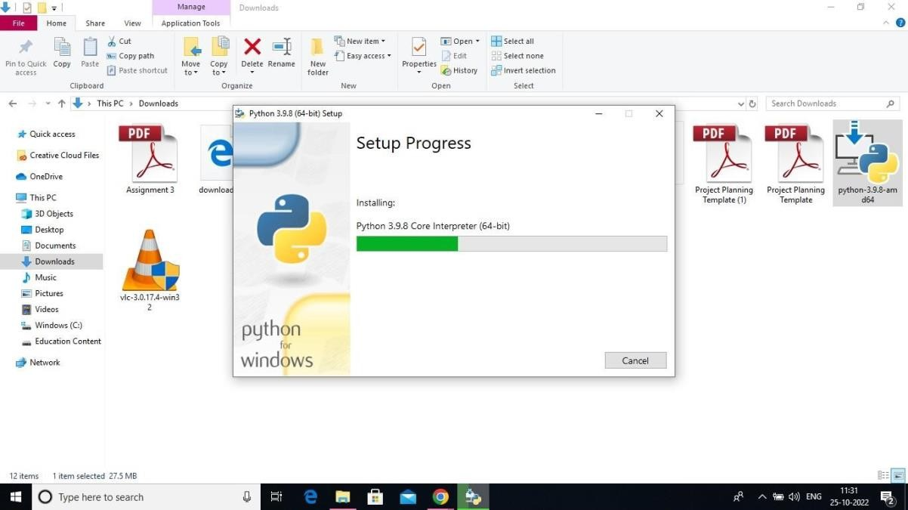

6:Close the button

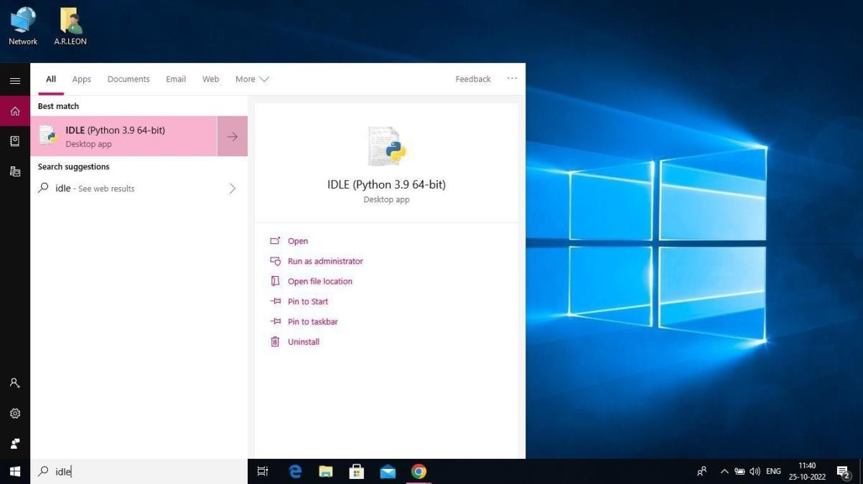

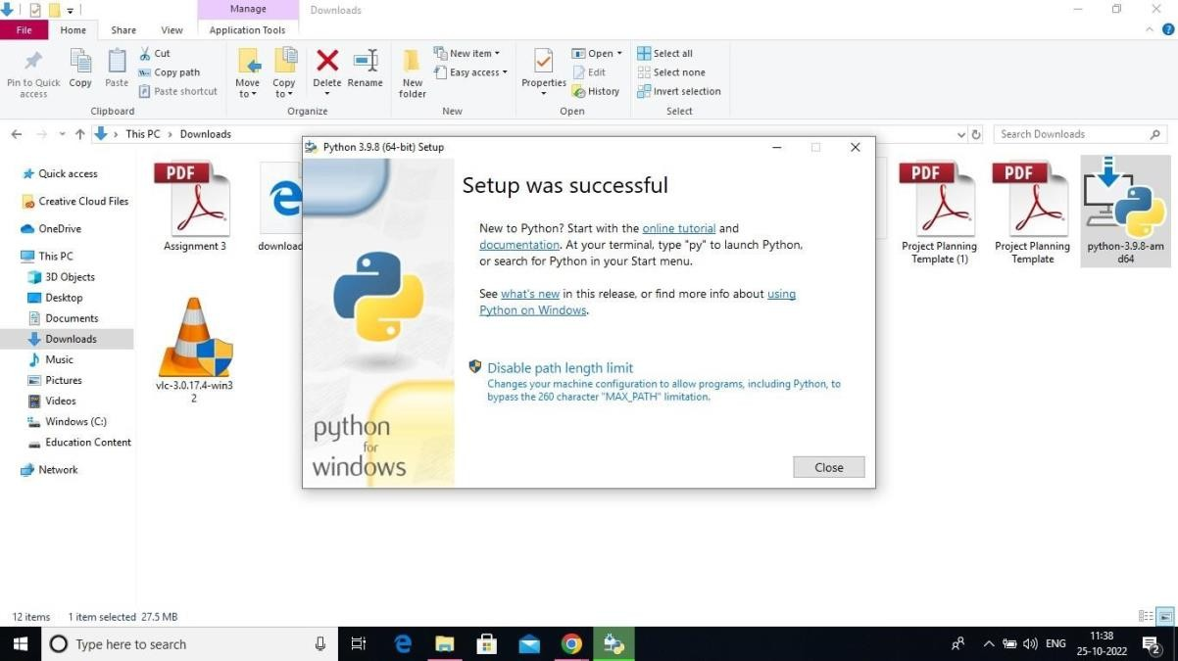

Step 7: Search IDLE 8: Open it

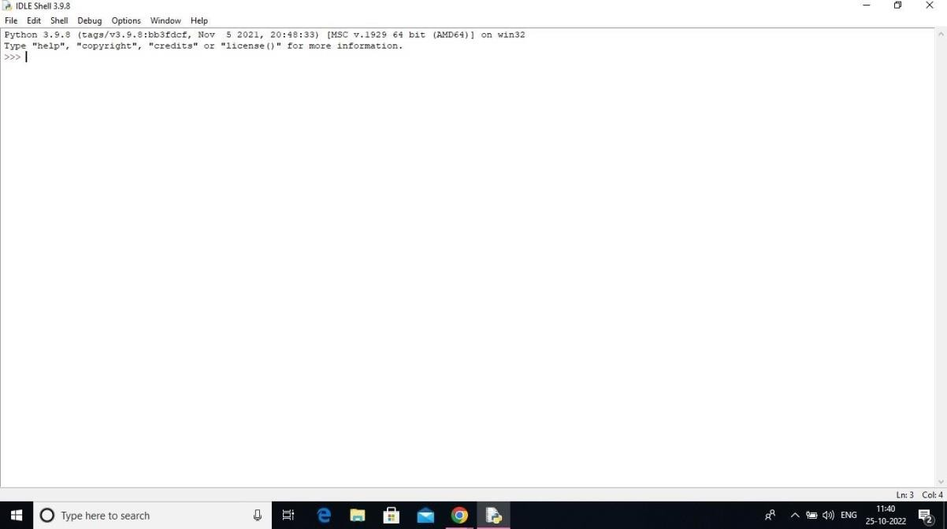

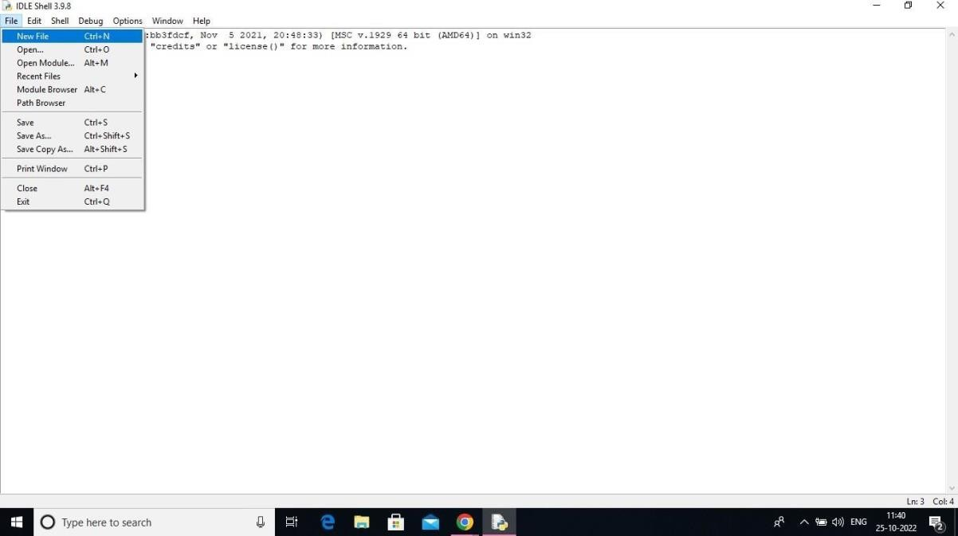Step 9: Go to file and click on New File

10: Open it

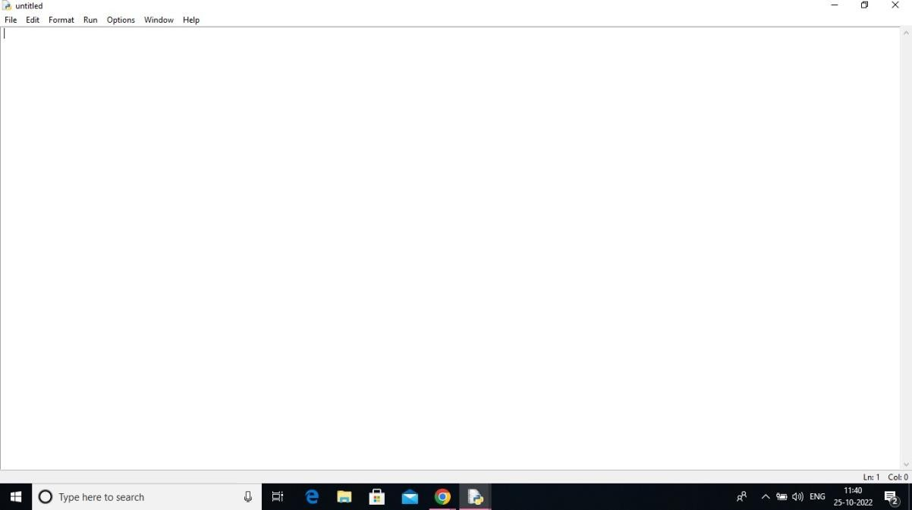

A Python 3.9.8 is installed successfully.